Race Track Program

# Introduction

crs_race_track is a program which facilitates the creation, execution and display of two-dimensional race tracks. This program supports:

* Creation of multiple tracks which run simultaneously
* Placement of cars on the tracks
* Adjusting car speed.
* Loading and saving of tracks

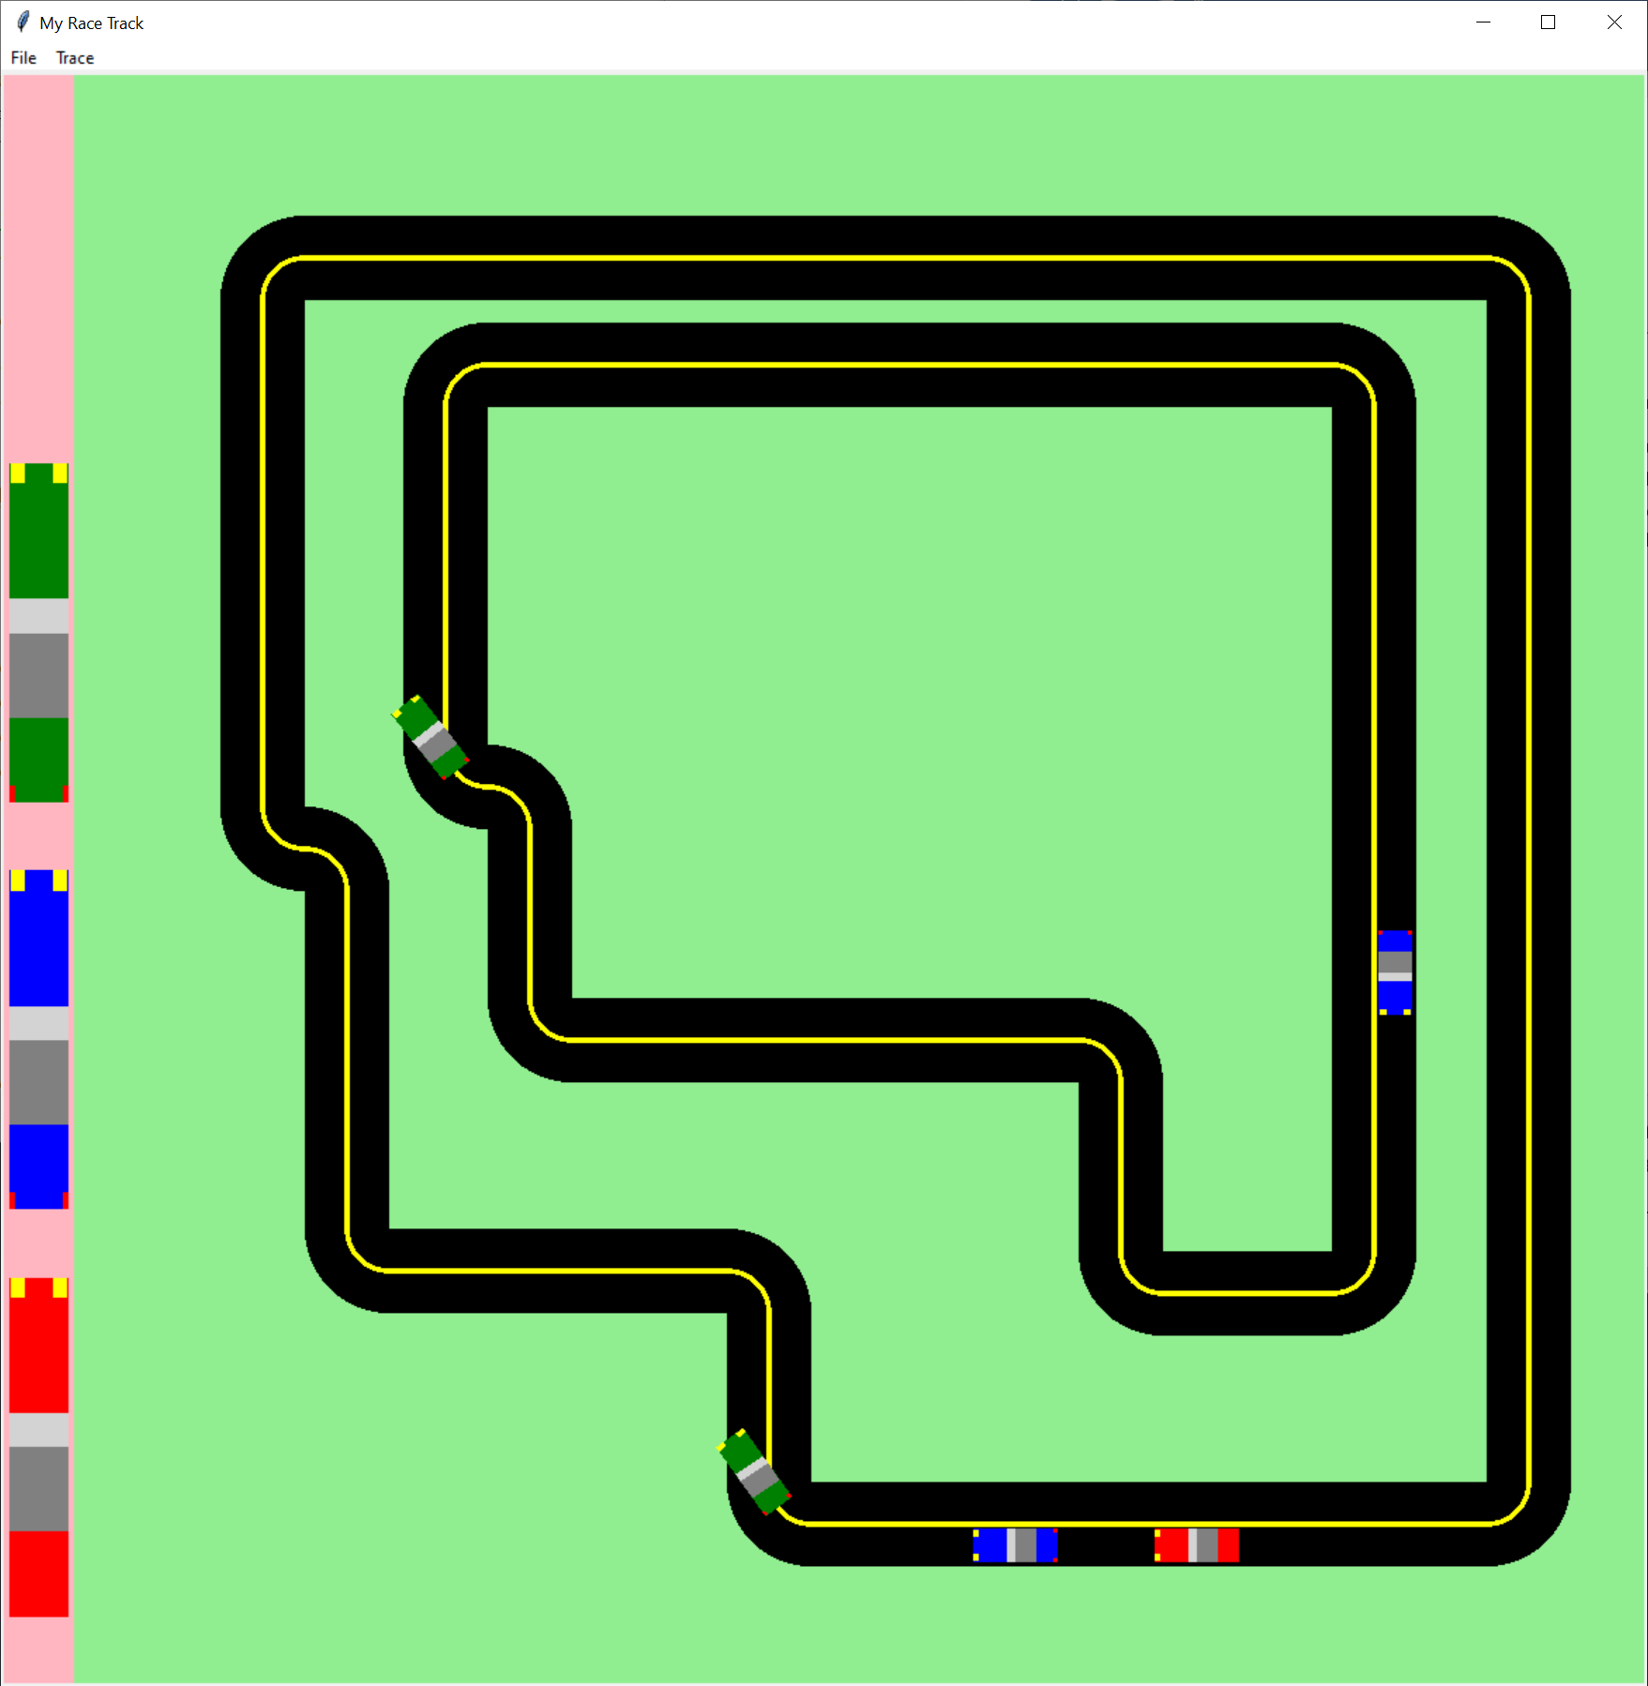

Race Track Display Window

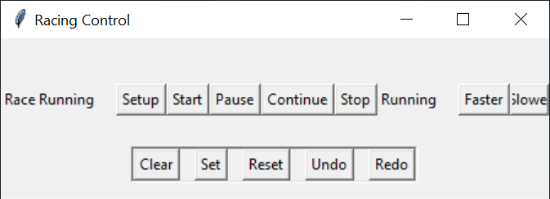

Race Track Execution Control Window

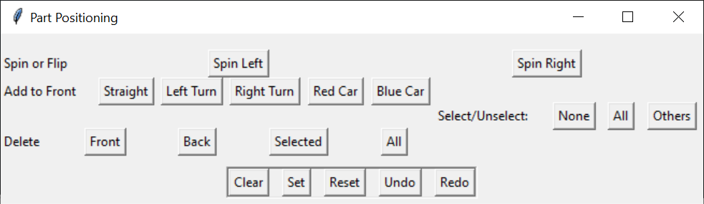

jRace Track Layout Control

# Major File/Modules

## File / Module Summary

* crs_race_tack.py – main program file
  + Executes game
  + Handles primary command inputs
* race_track.py – RaceTrack (RoadTrack, BlockMouse)
  + Race Track Window construction and control
  + Track construction
  + Bin construction
* road_bin_setup.py – RoadBinSetup
  + Setup materials add bin
* road_track_setup.py – RoadTrackSetup
  + Create road track from race track file
* road_block.py – RoadBlock (BlockBlock)
  + Part of a road
  + Used to construct a road
* road_panel.py – RoadPanel (RoadBlock)
  + Used to construct road layout
* road_strait.py – RoadStrait (RoadBlock)
  + Straight section of road track
* road_turn.py – RoadTurn (RoadBlock)
  + Turn section of road track
* car_block.py – CarBlock (BlockBlock)
  + Abstract car
* car_simple.py – CarSimple (CarBlock)
  + Simple abstract car

Figure Composition Components

* Block_block.py – BlockBlock
  + composite of geometrical things (currently 2-dimensional)
  + used to construct hierarchical graphical objects
  + Object properties are expressed in relation to the containing object (container),
  + else in relation to the canvas (cv_width, cv_height)
  + cv_width, cv_height are needed because canvas.wininfo are not always available.
* Based on BlockBlock: BlockArc, BlockCheck, BlockDot, BlackPanel, BlockPolygon, BlockRing, BlockText, CarBlock, RoadBlock

## crs_race_track.py – program main file

Sets up race controls and displays. Accepts program command line options. Controls program operation.

### Program flow

1. Process command line arguments
2. Setup main window via BlockWindow
3. Construct race track via RaceTrack
4. Construct road bin via RoadBinSetup
5. Construct can bin via CarBinSetup
6. Add road track via RoadTrackSetup If starter_track is True

1. program main loop via mainloop

During operation, on request:

* Save current track state to file
* Load track state from file